Walk 22 Brockhampton and The River Wye
Last walked in April 2016

Description. A 7 km (4.3 mile) walk over varied terrain of woodland, farmland and along a lovely stretch of the River Wye. The full walk involves one short steep down and another steep uphill section.
Start. Brockhampton church 8 miles South East of Hereford. Map 189 Grid 594321.
Direction from the Fire Station. (Turn milometer to zero) 200 yards passed the Fire Station TR signed 'Fownhope B4224'. Continue on thru Fownhope and at 6.2 miles you TR at the cross roads immediately before St Mary’s Church, signed 'Capler and Brockhampton Church’ and go along Capler Lane. Follow for 1.8 miles [8m] to turn L at -the cross roads and go downhill for 300 yards to park on the road by the church [8.1m]

1. |Brockhampton Church. Brockhampton church was built in 1902 and described by the architectural authority, Nicholaus Pevsner, as ‘One of the most convincing and most impressive of churches of its date in any country’. The architect and builder was Lethaby, a disciple of William Morris and the Arts & Crafts movement. Indeed there are two tapestries one each side of the altar made in the William Morris Workshop from designs by Edward Burne-Jones. The church is lovingly maintained by its parishioners even to the hand embroidered prayer book covers, each with a different wild flower. It is a must for a visit. With your back to the Lych Gate, cross the road and TR, walk for 20 metres and TL to go thru a gate into {F1}. Go down the valley to cross two fields {F1} & {F2} that are separated by a small wire fence, you can cross the fence going over wooden steps or by going thru a wooden gate. As you descend and near to the end of the fields Brockhampton Court will be on your L. Brockhampton Court was rebuilt in 1893 from an 18century rectory, it was the home of Alice Foster and her husband of the Yorkshire milling family, who had the church built in memory of her parents. It is now a Residental Home. At the end of the fields go over a stile/wooden gate onto a minor road and TR. Follow uphill to a road junction. Cross the junction to walk up an enclosed track leading uphill, to enter {F3}. Now follow the track with a hedge on your R thru two fields {F3} & {F4}. At the end of the second field go thru a wooden gate and then immediately R over a stile and into {F5}, follow the hedge on your R to join a grassy green lane. TL and follow the enclosed grassy green lane until it ends at an arable field. TR into {F6} and follow the track with the hedge on your L until you reach a minor road.

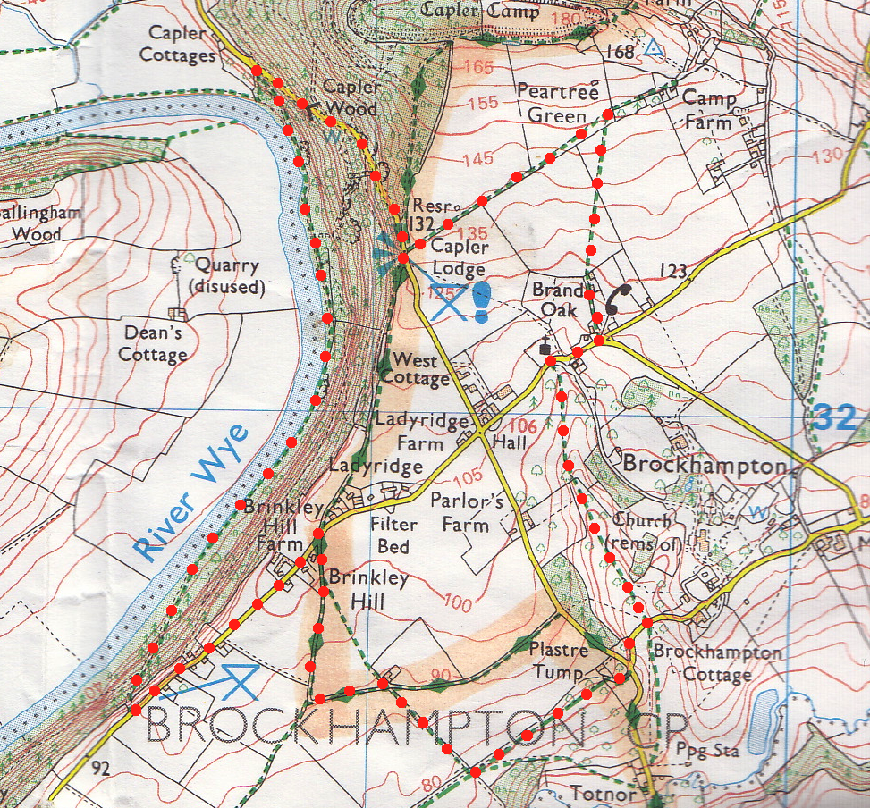
2. Minor Road. TL along the road for 700 metres, going thru a group of cottages, and just past the Welcome to Brockhampton road sign (L) reach a Picnic Site on your R. TR and take the track in the R corner of the site, going downhill thru the trees - mainly Sweet Chestnut. If it is wet be careful, especially on a short steep section, as the track is metalled and the stones can be slippery. On reaching the River Wye TR and walk along the river bank. Continue along the bank for about 1 km and follow the track as it swings away from the river, going gently uphill, follow the track up to a minor road. TR and go uphill for 700 metres, involving a short steep section of 1 in 6, to a Viewing Point on your R.

3. Viewing Point. Pause here for the spectacular view down the Wye Valley. Now with your back to the Viewing Point cross the road and TR for a few metres to TL onto a very short length of track into {F7}. Continue in the same direction keeping the hedge on your R. Uphill on the L hand side is Capler Camp, an Iron Age Hill Fort occupied between 500BC and 200/300AD. To the east, (half R) is Marcle Ridge and the Mast, Mary Hill with its distinctive crown of trees is to the south east and the Forest of' Dean along the skyline from south to south west. Continue thru two fields {F7} & {F8} and over two stiles. A few metres after the second, TR over another stile/metal gate into {F9}. Turn half R and cross this diagonally, cutting off the corner, to cross a stile in the hedge ahead into {F10}. Continue across {F10} to a gate on the R of a house. Go thru the gate and down a short lane to a minor road. TR and go 150 metres downhill back to the start.
3
2
1

